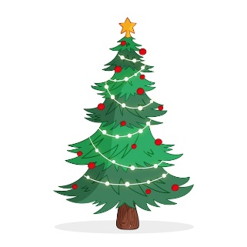The Council will be closed from 23rd December - 2nd January 2025.

The Council wish all residents a Merry Christmas and a Happy New Year.